**COURSELY USER MANUAL**

**Version 1.0**

**By: Christen Ford**

Contents

1: Introduction 3

2: Terminology 3

3: Pages 4

3.1: Home Page 5

3.2: Admin Pages 6

3.2.1: Manage University 6

3.2.2: Manage Courses 6

3.2.3: Manage Users 6

3.3: Instructor Pages 6

3.3.1: Manage Advisees 6

3.3.2: Manage Sections 6

3.4: Student Pages 6

3.4.1: Enroll for Class 6

3.4.2: Manage Schedule 6

3.4.3: View Record 6

3.5: Catalog page 6

3.5: Account Page 7

3.6: Login Page 8

4: Conclusion 9

# 1: Introduction

Welcome to Coursely! Coursely is packed with features meant to make managing your university easier. First, Coursely allows administrators to create and manage courses, course sections, schools, majors, departments, buildings, and users. Second, instructors can manage their course sections, as well as their advisees. Third, students can manage their schedule, and view their academic record. Finally, Coursely acts as a course catalogue system. All users can view the course catalog including guests that do not have an account with Coursely. Coursely is purpose built to be a lightweight, minimalist system with a low learning curve. With that said, let’s begin!

# 2: Terminology

This section covers the terminology that you may encounter while using Coursely. If at any time you are using the system and become confused as to what something means, you can find it explained here.

* Administrator: One of three roles within the Coursely system. An administrator is responsible for creating and managing both users and university objects such as buildings, courses, departments, schools, and sections. Only administrators have access to the advanced features of Coursely.
* Building: A building in Coursely is meant to reflect a real-world building at your campus. They have both a name and abbreviation. Administrators must provide a building (and a room number) before they may create a section.
* Course: Courses are one of the main university objects within Coursely. They are used extensively by the system both within the catalogue as well as when creating course sections. A section must be associated with a course.
* Department: A department with Coursely represents a department within an academic school at your university. Courses must be associated with a department. Likewise, instructors must also be associated with at least one department.
* Instructor: One of three users within Coursely. Instructors can manage their advisees as well as their courses. In their role as an advisor, instructors can view their advisees academic record as well as their schedule for a given term. In addition, advisors can override a course’s prerequisites to enroll a student in a course.
* Major: Represents a student major. Each student is required to have at least one major.
* Prerequisite: Coursely uses prerequisites to prevent students from enrolling in courses that they are not academically prepared for. Instructors can provide an override for a course’s prerequisites for their advisees. A course may have multiple prerequisites.
* School: Represents an academic school at your university. Departments must be associated with a school.
* Section: Represents a course section. Students enroll in sections and instructors teach sections. A section is always associated with a term
* Student: Represents a student at your university. A student can manage their schedule and view their record.
* Term: Represents an academic term. Coursely uses quarter-based terms. That is, Coursely provides the following semesters: Spring, Summer, and Fall. A term must also be associated with a year. Sections are organized based on their term.
* University Identifier: A unique identifier meant to represent a user of Coursely. This should reflect the identification number assigned to members of your university body. It is required that a university identifier be a number consisting of six to nine characters. Leading zeros are included in the university identifier.

# 3: Pages

Coursely is a web-based platform. In addition, Coursely requires that users have an account with the system to access most of its pages. Accounts may only be created by an administrator. If you do not have an account, contact a person assigned to be a Coursely administrator at your university. There is a consistent look and feel across the entire Coursely web site to ensure that you do not become confused while using the system. Also, each page maintains a banner at the top that allows you to navigate to the major pages of the site. This banner changes depending on whether you are logged in as well as your role within Coursely.

The home page may be visited any time by clicking the ‘Home’ button in the banner at the top of the page. You may view the course catalog regardless of whether you are logged in or not. Simply click on the ‘Catalog’ button in the banner and you will be taken to the Catalog page. Likewise, if you are logged out, you may login to Coursely by clicking on the ‘Login’ button to the right of the ‘Catalog’ button in the banner. If you are logged in, then there will be an additional ‘Account’ button to the right of the ‘Catalog’ button that will take you to the ‘Manage Account’ page when you click on it. Likewise, clicking the ‘Logout’ button while logged in will log yout out of the system.

## 3.1: Home Page

This is the first page you will see when visiting the Coursely web site. There is not much to be seen on this page (at least in version 1.0 of the Coursely software). Use the banner at the top of the page to navigate the web site. The home page differs depending on whether you are logged in or logged out.

If you are logged out, the Coursely home page takes the following appearance:



Figure : Coursely Home Page (Logged Out)

If you are logged in, then the home pages appearance depends on your role. A second banner will appear with varying options depending on if you are an Administrator, Instructor, or Student.

If you are an Administrator, then the home page has this appearance:

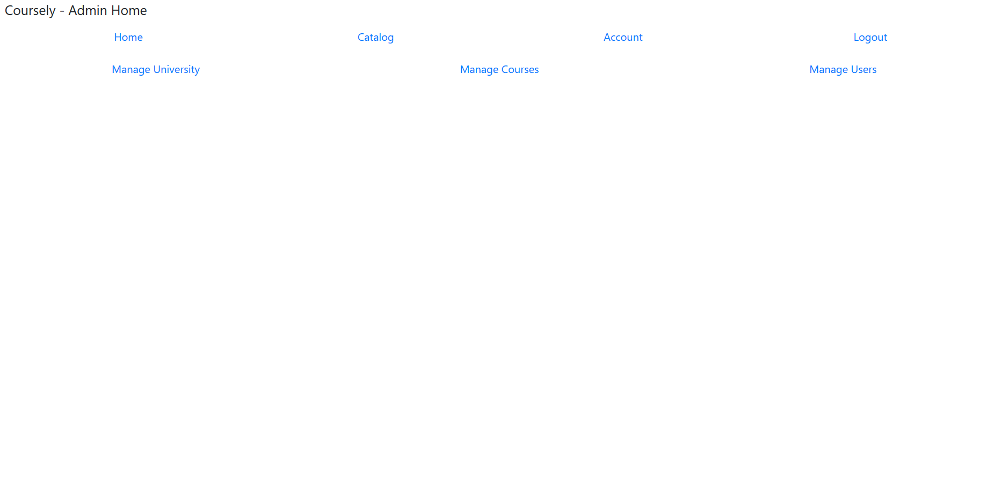

Figure : Coursely Home Page (Administrator)

First, the ‘Manage University’ button allows you to manage objects related to your university such as buildings, departments, majors, and schools. Next, the ‘Manage Courses’ button allows you to manage courses and course sections. Finally, the ‘Manage Users’ button allows an administrator to create new users.

If you are an Instructor, then the home page has this appearance:



Figure : Course Home Page (Instructor)

The ‘Manage Advisees’ button allows an Instructor to manage their advisees. This includes the ability to view schedules, and records, as well as override prerequisites for a student who wants to enroll in a course they do not meet the prerequisites for. While, the ’Manage Sections’ button allows an Instructor to view the sections they are scheduled to teach for a given term.

Finally, if you are a student, then the home page has this appearance:

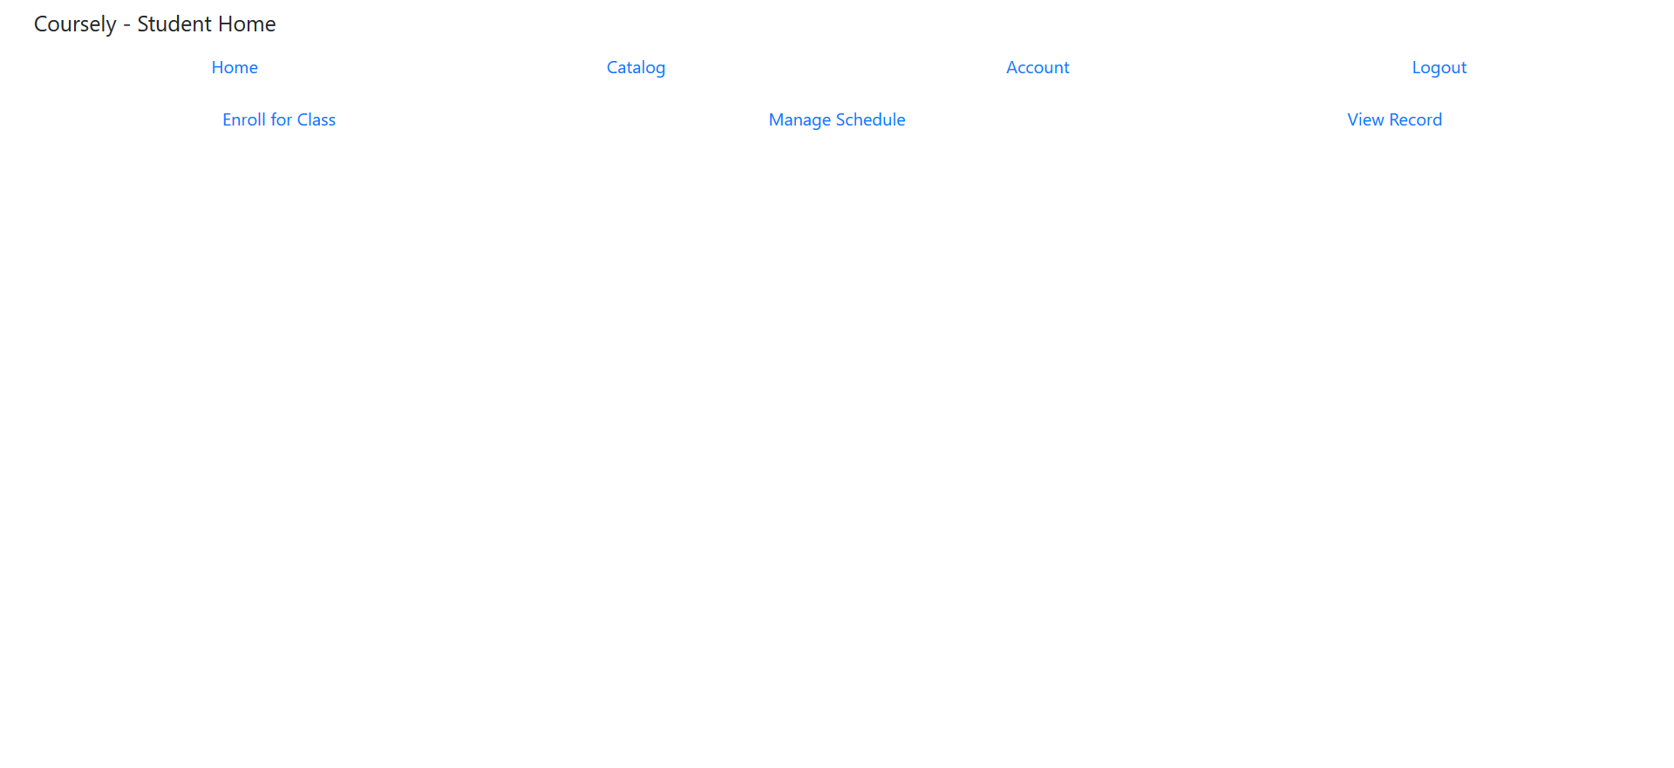

Figure : Course Home Page (Student)

## 3.2: Admin Pages

These pages are unique to the Administrator role. They are not accessible by anyone who is not an Administrator.

### 3.2.1: Manage University

This page allows an Administrator to create and modify buildings, departments, majors, and schools. You navigate this page by utilizing the tabs at below the banner. It has the following appearance:

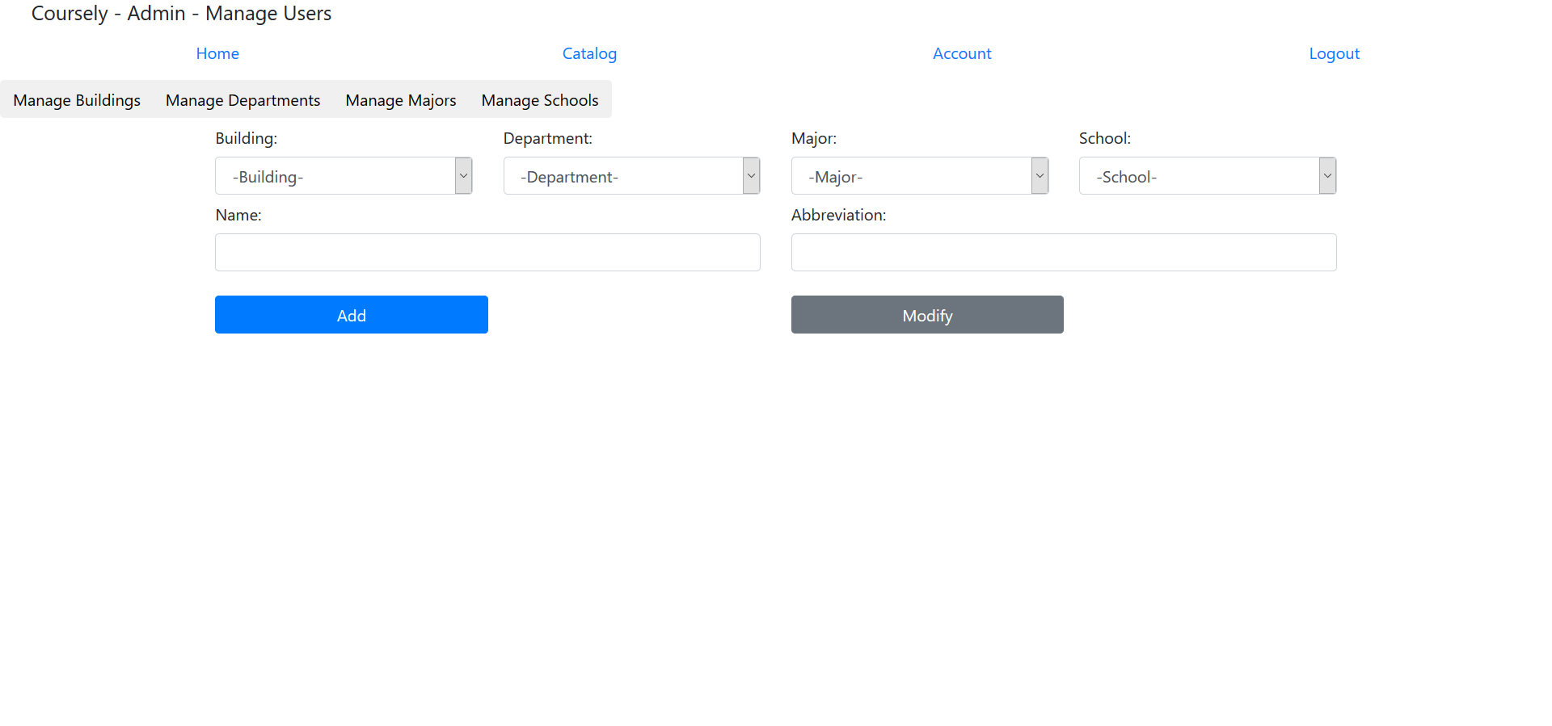

Figure : Manage Users Page (Administrator)

To create a university object, first select the tab then enter in the information into the input fields on the page. Finally, click the ‘Add’ button. The system will respond with a message indicating the whether the object was successfully created or not. If you input an invalid piece of information, the system will not process the request to add the object and will instead inform you that there was an error creating the object. The system will also display what piece of information was incorrect.

To modify a university object, use one of the provided dropdowns to select it. The page will refresh, and the objects information will be loaded into the input fields on the screen. Navigate to the correct tab and modify the object accordingly. Once finished, click the ‘Modify’ button. The process the system uses for modifying an object is the same as what it uses for adding an object. That is, you will receive similar output as you would when adding an object.

### 3.2.2: Manage Courses

This page is used by administrators to add and modify courses as well as to add and modify sections. The ‘Manage Courses’ page has the following appearance:

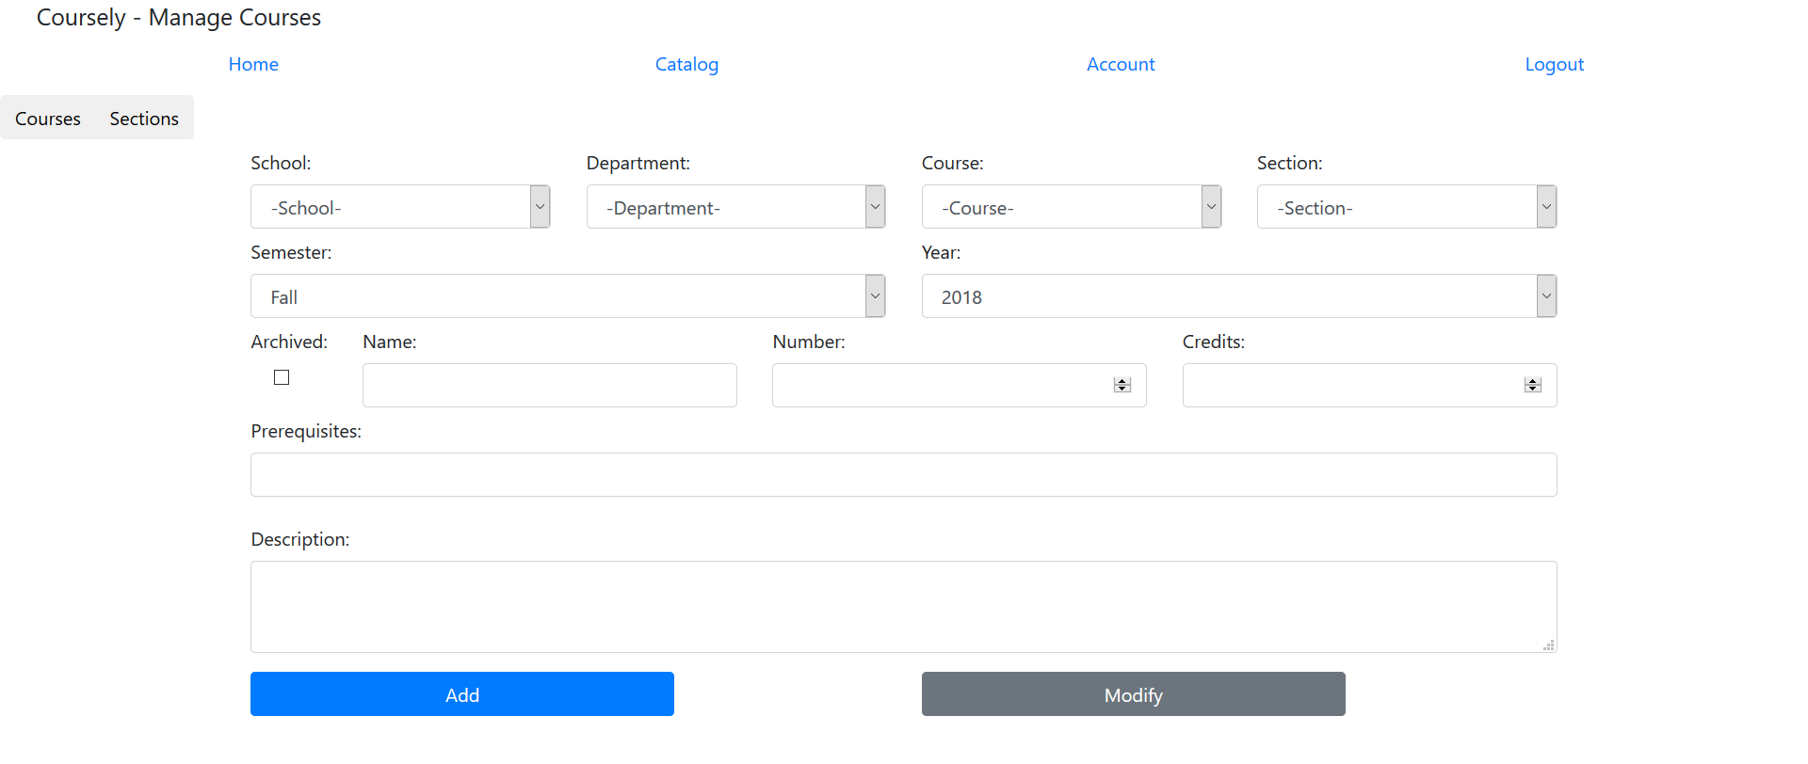

Figure : Manage Courses Page/Course Tab (Administrator)

To add a course, you must select a school and department as well as a name, number, number of credit hours, optional prerequisites, and a description. The system will inform you if you enter any information incorrectly.

In the case of prerequisites, they must take the form of (DEP P AND DEP Q OR DEP R). For example, ‘CSC 100 AND CSC 125’ is a valid prerequisite that would require students to have taken both CSC 100 and CSC 125. In the case of an OR, then the prerequisites on the left of the OR will be treated as one group while the prerequisites to the right of the OR will be treated as another. This pattern applies up the point where another OR is encountered. Prerequisites that are ANDed together are treated as one group. Do not enter any parenthesis when entering course prerequisites, Coursely is not designed to handle them. They will be treated as invalid input.

To modify a course, you must additionally select a Course using the indicated dropdown. The input fields in the ‘Course’ tab will then be populated with that course’s information. You may make your changes and click the ‘Modify’ button. The system will inform you whether the modification request was successful or not as well as the error if one occurred.

The process to add a section is similar to that of a course. The ‘Section’ tab has the following appearance:

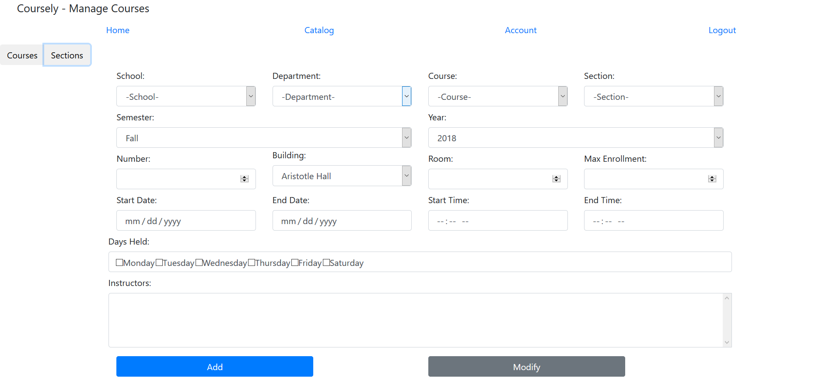

Figure : Manage Courses Page/Section Tab (Administrator)

You are required to enter information for each input field on the screen. To select multiple instructors for a section, you must hold the Ctrl button while selecting the instructors. To modify a section, first select a semester and year, then select a school, department, course, and section. The display will then be updated to reflect the chosen sections information. Clicking the ‘Add’ button will attempt to add the section to the database, while clicking the ‘Modify’ button will attempt to update an existing section.

### 3.2.3: Manage Users

This page is used by administrators to add users to the system. It has the following appearance:

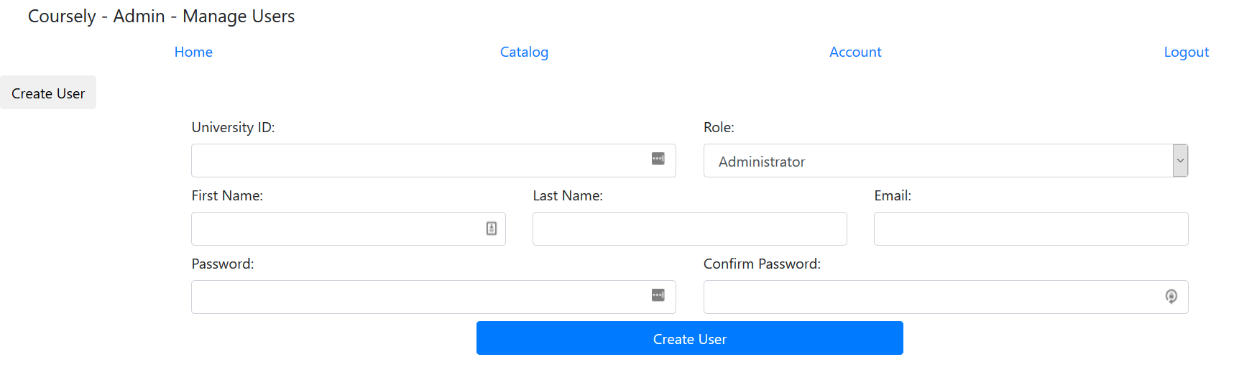

Figure : Manage Users Page (Administrator)

All the information displayed in this image must be input by the administrator before they may create a user. Extra information will be displayed dependent on the role. If the user is an instructor, then the administrator will additionally have to select at least on department for the instructor to belong to. However, if the user is a student, then the administrator will have to select at least one major, as well as one advisor for the student. To select multiple advisors, departments, or majors, you must hold the Ctrl button on your keyboard and click on each advisor, department, or major.

## 3.3: Instructor Pages

These pages are unique to the Instructor role. They are not accessible by anyone who is not an Instructor.

### 3.3.1: Manage Advisees

This page allows an instructor to manage their advisees. This includes the functionality of viewing an advisee’s academic record and schedule. Additionally, the instructor can override the prerequisites of a course for a student and enroll them in a section even if they do not meet the courses prerequisites. It has the following appearance:

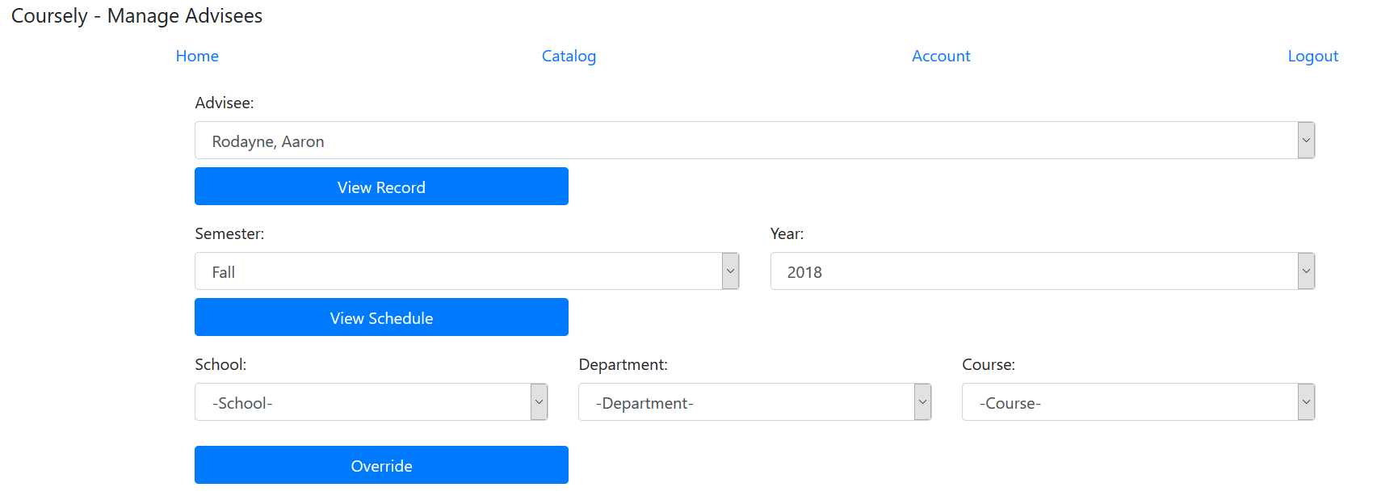

Figure : Manage Advisees Page (Instructor)

Before you may view an advisee’s record or schedule, you must first choose the advisee using the dropdown. To view their record, you simply click the ‘View Record’ button. Coursely will either display their record on screen in a table, or it will inform you that the advisee does not have any grades to display. To view an advisee’s schedule, you must first select a semester and year. Finally, you must click the ‘View Schedule’ button. Coursely will either display the advisee’s schedule on screen in a table, or it will inform you that the student is not enrolled in any courses for the indicated term.

To override prerequisites for a student, you should first view their schedule for term you wish to provide an override for. This will allow you to see the student’s schedule first. You must also select the semester and year, which comes along with viewing the advisee’s schedule. After selecting a semester and year, you must select a school, department, and course. After selecting a course, Coursely will automatically display the course’s sections and display them on screen (of the course is offered during that term). If you are satisfied that the student will be successful in the course, select the section from the list that appears and click the ‘Override’ button. Coursely will inform you whether the override was successful or not.

### 3.3.2: Manage Sections

This page allows an instructor to view the courses they are scheduled to teach for a given term. It has the following appearance:

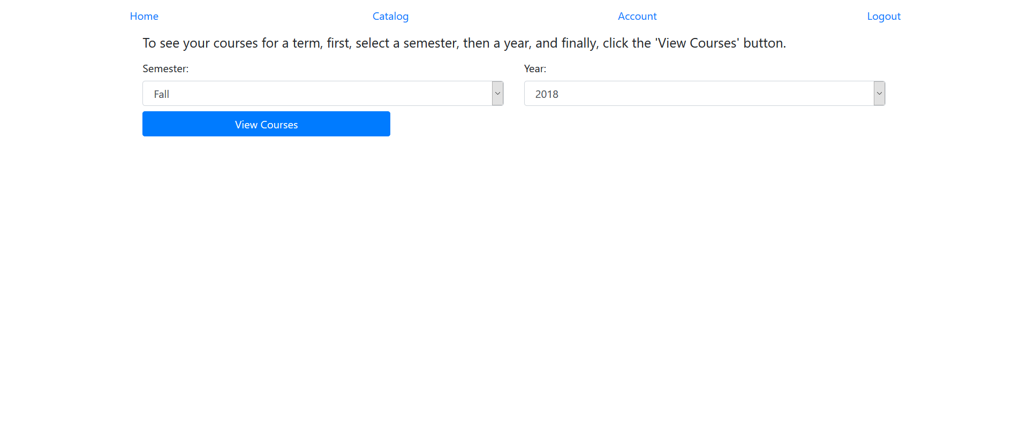

Figure : Manage Sections (Instructor)

To view the courses you are scheduled to teach for a given term, first select the semester, then year. Finally, click on the ‘View Courses’ button. Coursely will either display your courses in a table on screen or will inform you that you are not scheduled to teach any course for the given term.

## 3.4: Student Pages

These pages are unique to the Student role. They are not accessible by anyone who is not a Student.

### 3.4.1: Enroll for Class

This page allows a student to enroll in classes. It has the following appearance:

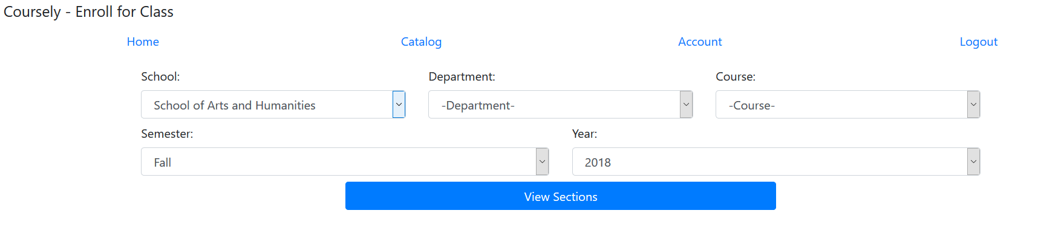

Figure : Enroll for Class Page (Student)

To enroll in a course, the student must first select a school, department, and course. Next the student, must select a semester and year. Finally, the student must click on the ‘View Sections’ button. Either a table will appear with the sections offered during that term, or a message will appear indicating the student that the course is not offered during that term.

If the table appears, then the student is free to choose a section from the list that appears below it. After they make their choice, they would click on the ‘Enroll’ button. The system will display a message indicating if they were successfully enrolled in the section or not.

### 3.4.2: Manage Schedule

This page allows a student to manage their schedule. It has the following appearance:

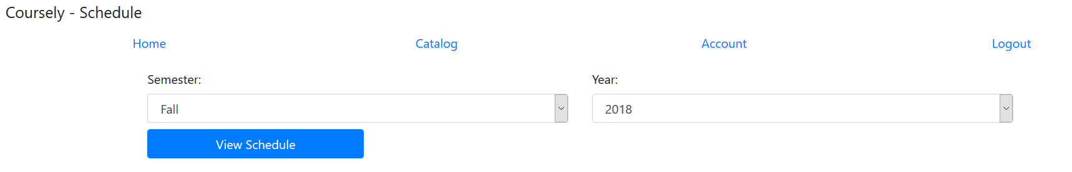

Figure : Manage Schedule Page (Student)

To view their schedule for a given term, the student must first select a semester and then a year. The system will prevent the student from viewing their schedule from previous terms and will only display the current term as well as the next five terms forward into the next two years. Once the student selects a semester and year, they would then click the ‘View Schedule’ button. The system will respond by either displaying the student’s schedule in a table on screen, or they will be told they are not enrolled for courses during the selected term.

### 3.4.3: View Record

This page allows a student to view their academic record. It has the following appearance:

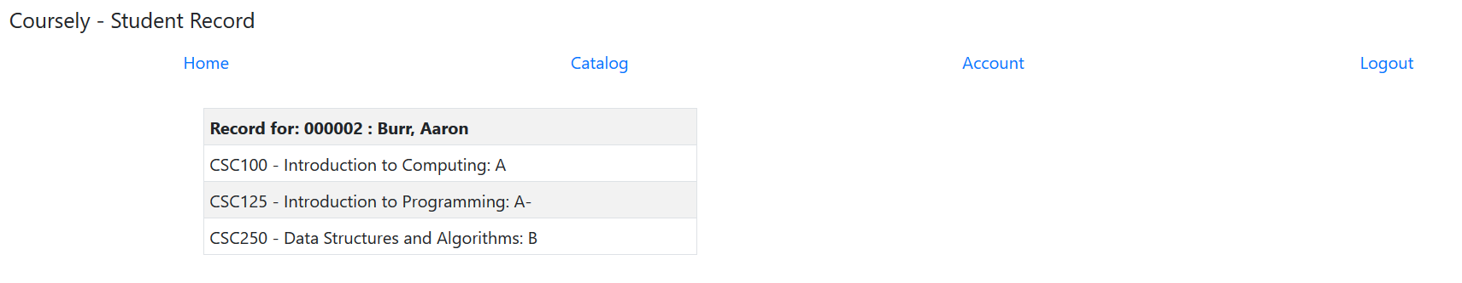

Figure : Student Record Page (Student)

Visiting the page will cause Coursely to automatically retrieve the student’s academic record and display it on screen. If the student does not have a record, then the system will inform the student that they do not have any grades to display.

## 3.5: Catalog page

This page is accessible by anyone whether they have an account with the Coursely system or not. It exists to allow users to view the course catalog at their university.

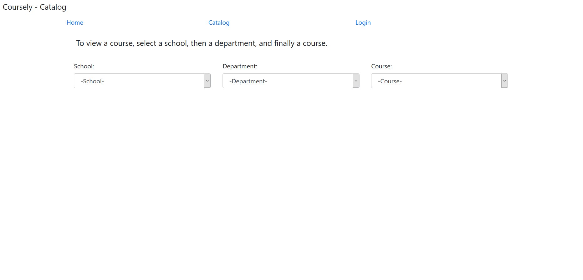

Figure : Catalog Page (All Users)

As indicated on screen, you may view a course by selecting a school, then a department, and finally a course. The page will refresh with the selected course’s information displayed on screen like so:

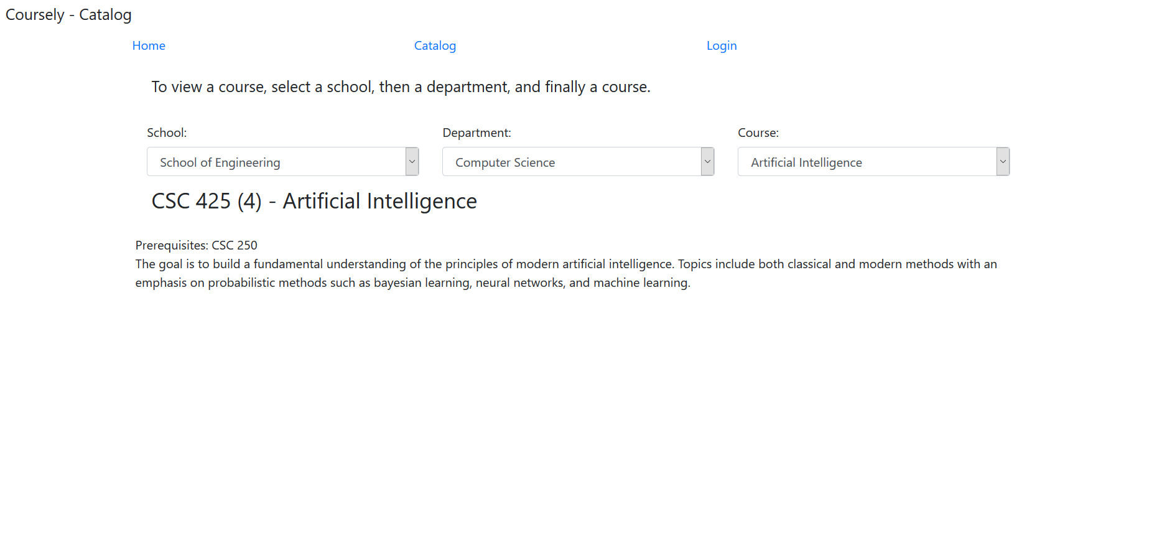

Figure : Catalog Page (All Users)

## 3.5: Account Page

The ‘Account’ page allows a user to manage their account. This page exists to allow the user to change their email or password. It also lists information pertinent to their account such as their email university identifier, name, or role. It has the following appearance:

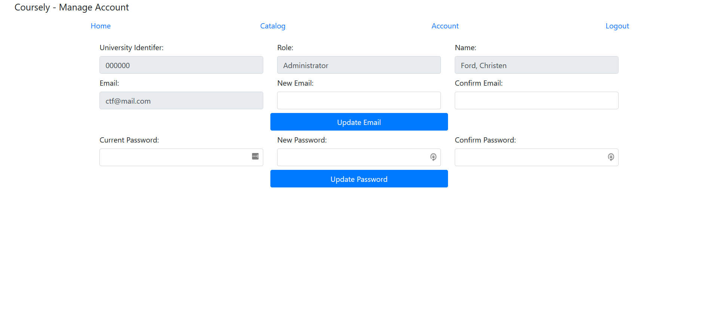

Figure : Account Page (Registered Users)

You may change your email by entering an email into both the ‘New Email’ and ‘Confirm Email’ fields and then clicking the ‘Update Email’ button. Likewise, a similar procedure may be used to change your password. However, as a security measure, you are also required to enter your current password in the ‘Current Password’ field as well. Once done, the system will notify you whether your email or password was successfully changed.

## 3.6: Login Page

You must visit this page to login to the Coursely system. It has the following appearance:

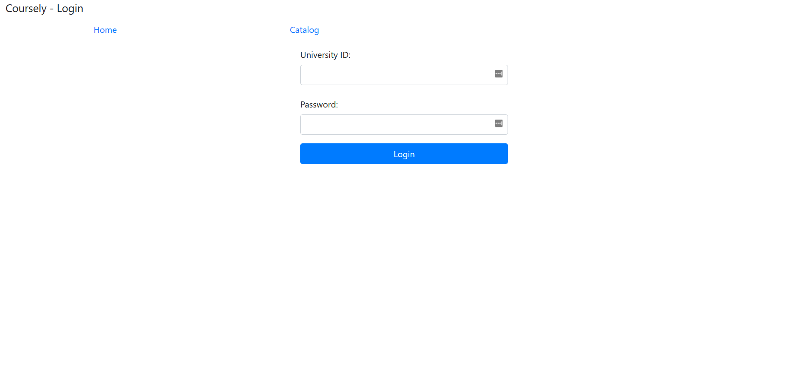

Figure : Login Page (All Users)

To login, you must enter your university identification number into the ‘University ID’ field and your password into the ‘Password’ field. If you entered the correct university identifier and password, then you will be taken to the accounts respective home page as defined above. Otherwise, you will receive the following error:

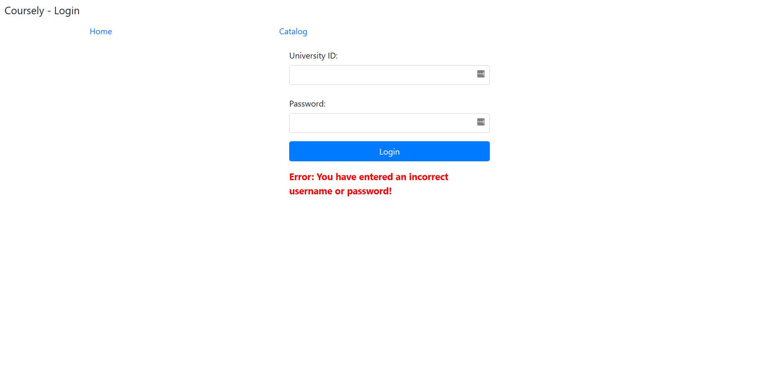

Figure : Login Page/Bad Input (All Users)

# 4: Conclusion

I have tried to be as thorough as possible with this manual under rigid time constraints. Please be aware that this manual is for version 1.0 of the Coursely software. It will likely be invalid for future versions of the software and should not be used for future versions of the software. If you encounter any issues with this manual, or have any suggestions or improvements, please visit <https://github.com/gollum18/CourseRegistrationPOC> and open an issue by clicking on the ‘Issues’ tab, and then the green ‘New issue’ button.